**Normal Distribution**

### **Normal Distribution (Gaussian Distribution) 📊**

A **normal distribution** is a symmetric, bell-shaped probability distribution that is widely used in statistics and data science. It is characterized by the **mean (μ)** and **standard deviation (σ)**.

### **Key Properties of Normal Distribution**

1. **Symmetry** – The distribution is perfectly symmetric around the mean.
2. **Mean = Median = Mode** – All three central values are the same.
3. **68-95-99.7 Rule (Empirical Rule)**
   * **68%** of data falls within **1 standard deviation (σ)** from the mean.
   * **95%** of data falls within **2σ**.
   * **99.7%** of data falls within **3σ**.

### **Formula for Normal Distribution**

The **Probability Density Function (PDF)** of a normal distribution is:

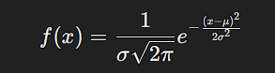

Where:

* xxx = data point
* μ\muμ = mean (average)
* σ\sigmaσ = standard deviation
* eee = Euler’s number (~2.718)

### **Examples of Normal Distribution in Real Life**

* Heights of people
* IQ scores
* Exam scores
* Stock market returns (approximate)

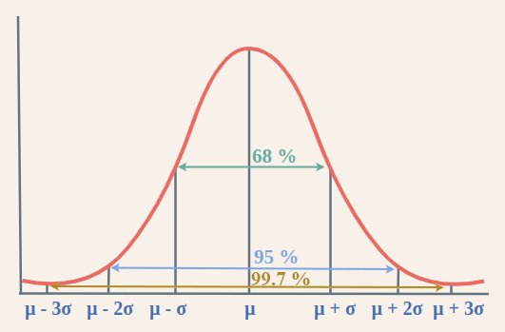

Empirical Rule states that,

68% of the data approximately fall within one standard deviation of the mean, i.e. it falls between {Mean – One Standard Deviation, and Mean + One Standard Deviation}

95% of the data approximately fall within two standard deviations of the mean, i.e. it falls between {Mean – Two Standard Deviation, and Mean + Two Standard Deviation}

99.7% of the data approximately fall within a third standard deviation of the mean, i.e. it falls between {Mean – Third Standard Deviation, and Mean + Third Standard Deviation}